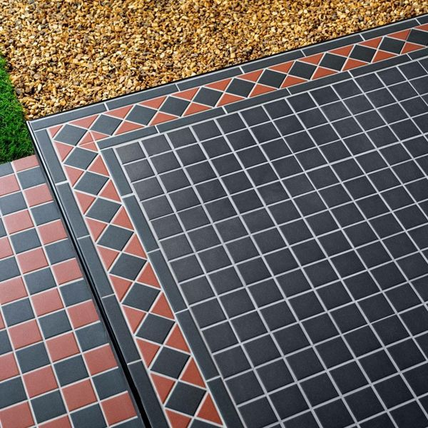**Churchill Midnight Mosaic:**

## **Product Description**

Inject a stylish period look into your home or garden with the introduction of these Churchill Midnight Mosaic Tiles. they're made from durable porcelain, so they're frost proof, and can be used in the garden to create a patio area. They're also suitable for use with underfloor heating.

The individual tiles measure 45x45mm. There are 36 tiles per sheet and 11 sheets per Sqm.

Once the tiles are laid we recommend using the [LTP Porcelain Tile Protector](https://www.wallsandfloors.co.uk/ltp-porcelain-tile-protector) before grouting for the best finish.

## **Product Info**

* Product ID: 41050
* Tiles Per SQM: 11.80902445649
* Sale by: Per Sheet
* Size: 291x291x6mm
* Weight: 1.00 KG
* Material Type: Porcelain
* Finish: Matt
* Colour: Black/Charcoal
* Suitability: Floors, Walls
* Area Of Usage: External
* Grade: 5
* Rectified Edge: No
* Underfloor Heating: Yes
* Anti Slip Grade: R11 / 12 Degrees
* Thickness (mm): 6